Customer

Line busy / No answer

1.2

Order’s food

1.0

Phone rings

Rotherham Kebabs DFD

Phone

Music stops

Told wait time estimate

Reaches first in que

1.1

Put on hold in que music plays

4.0

Driver contacted

FOHS Answers phone

Process repeats

Gives payment to FOHS

Driver heads to store

4.3

Paid by customer

4.2

Driver travels to desired drop off point

Order collected

4.1

Waits for new order

Notify FOHS

3.2

Cleans work station

3.1

Order stored

Order cooked

Driver heads to store

3.0

Cook’s order

Information

passed along

Information passed along

Information passed along

Information passed along

Information passed along

Information passed along

Kitchen staff

FOHS writes notes on paper

Driver

Order information

A1

FOHS Take details

2.0

Customer

Order’s food

1.2

Rotherham Kebabs DFD

Internet

1.1

Waits 5 minutes

Order confirmed

Notification Received

No notification

Refresh page

Manager begins to print out order

4.0

Driver contacted

Manager

1.0

Process repeats

Gives payment to FOHS

Driver heads to store

4.3

Paid by customer

4.2

Driver travels to desired drop off point

Order collected

4.1

Waits for new order

Notify FOHS

3.3

Cleans workstation

3.1

Order stored

Order cooked

Driver heads to store

3.0

Cook’s order

Information

passed along

Information passed along

Information passed along

Information passed along

Information passed along

Information passed along

Kitchen staff

Manger passes print out

Driver

Order information

A1

Order printed

2.0

Looks for notification

Logs onto website

Customer

1.1

1.0

Rotherham Kebabs DFD

In shop

Customer ready to order

Customer looks at menu

Unsure on what to order

FOHS Ask if would like to order

Walks into store

FOHS gets note pad

Waits for new order

Notify FOHS

3.2

Cleans work station

3.1

Order stored

Order cooked

3.0

Cook’s order

Information

passed along

Information passed along

Information passed along

Kitchen staff

FOHS writes notes on paper

Order information

A1

FOHS Take details

2.0

Gives correct change

FOHS Gives order to customer

3.3

FOHS Take’s payment

2.2

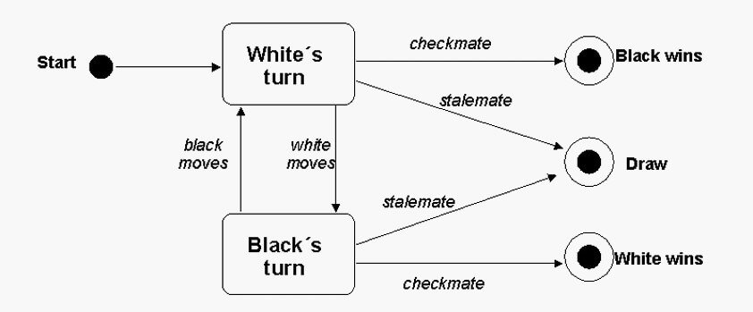

Payment declined

Payment verification

Processing order

Order requested

`x

Display order on screen in kitchen

Invoice and payment sent

In stock

Order declined tells manager and customer out of stock

Out of stock

Check’s inventory

Payment approved

Start